

**AMERICAN INTERNATIONAL UNIVERSITY–BANGLADESH (AIUB)**

**FACULTY OF SCIENCE & TECHNOLOGY**

**INTERNSHIP AFFILIATION REPORT ON**

***Teaching Assistant in Advance Database Management System***

An Internship Report Presented to the

OFFICE OF PLACEMENT and

DEPARTMENT OF COMPUTER SCIENCE

In Partial Fulfillment of the Requirements for the Degree

***Bachelor of Science in Computer Science and Engineering***

**Supervised By**

**Dr. Dip Nandi**

**Associate Professor, Director**

**Faculty of Science & Technology**

**American International University–Bangladesh**

**Submitted By**

**Kabir, Shahriar**

**ID: 18-37094-1**

2021-2022, Summer

Date of Submission: **August 14, 2022**

# LETTER OF SUBMITTAL

10th August, 2022

Dr. Dip Nandi

Professor and Director

Faculty of Science and Technology

Subject: Submission of Internship Report on “Intern Student at American International University-Bangladesh”.

Dear Sir,

I feel really very honor to submit my internship affiliation report titled " As a teaching assistant at AIUB" to you. I was assigned for the course ADVANCE DATABASE MANAGEMENT SYSTEMS as a teaching assistant. I had done internship under a very respected and friendly faculty REZWAN AHMED sir. He treats me like a guardian. Basically, my task in the lab was to help the student when the face problems during their lab task, unable to understand something related to course. These gave me some experience on how to help the student and interact with them for their better understanding. The experience that i have gathered will be extracted in this report. I am very grateful to get such an opportunity that gave me a lot of experience.

Sincerely Yours,



Kabir, Shahriar

ID: 18-37094-1

Computer Science Engineering

American International University - Bangladesh

**LETTER OF ENDORSEMENT**

The Internship Affiliation Report entitled “*As a Teaching assistant at American International University - Bangladesh (AIUB)*”, has been submitted to the Office of Placement and Department of Computer Science in partial fulfillment of the requirements for the degree of *Bachelor of Computer Science and Engineering* by *Kabir Shahriar, 18-37094-1*. This report is presented to the Internship Defense Committee for evaluation and has been accepted.

|  |  |  |
| --- | --- | --- |
|  |  |  |
| Dr. Dip Nandi  *Internship Supervisor* (Academic)  Professor and Director  Department of Computer Science  Faculty of Science and Technology  American International University Bangladesh |  | Rezwan Ahmed  *Internship Supervisor* (Organization)  Assistant Professor  Department of Computer Science  Faculty of Science and Technology  American International University Bangladesh |
|  |  |  |
| Md. Nazmul Hossain  *Internship Supervisor (External)*  Lecturer  Department of Computer Science  Faculty of Science and Technology  *American International University Bangladesh* |  | Dr. Dip Nandi  *Internship Supervisor* (Academic)  Professor and Director  Department of Computer Science  Faculty of Science and Technology  American International University Bangladesh |

**ACKNOWLEDGEMENT**

First of all, I would like to thank almighty Allah, for his grace in accomplishing my internship report timely.

I would like to express my gratitude to the **Faculty of Science & Technology** to keep internship credit in the curriculum of the graduation program and give me a scope of tasting the flavor of industry-oriented tasks and the field of work with my interest. I am also grateful to the **Faculty of Science & Technology & Office of Placement & Alumni**, AIUB to arrange an opportunity for choosing an own interested organization and complete internship there.

I am also thankful to my organization supervisor **Dr. Dip Nandi**, Professor and Director, Department of Computer Science, American International University - Bangladeshfrom the core of my heart for his kind support, guidance, constructive, supervision, instructions and advice and for motivating me to do my internship smoothly at *American International University – Bangladesh (AIUB)*.

I feel proud and gratified that I was always held the under supervision of **Rezwan Ahmed,** Assistant Professor at American International University – Bangladesh. Here, with daily reporting along with mental and professional support enhances my experience in the internship life.

Finally, I would like to express my appreciation to everyone who helped me successfully complete my internship, and I apologize for not being able to thank everyone individually. I am confident in my capacity to complete the assigned report accurately and consistently.

# TABLE OF CONTENTS

|  |  |
| --- | --- |
| **TOPICS** | ***Page no*.** |
| 1. **Title Page** | 1 |
| 1. **Letter of Submittal** | 2 |
| 1. **Letter of Endorsement** | 3 |
| 1. **Acknowledgement** | 4 |
| 1. **Table of Content** | 5 |
| 1. **List of Tables &Figures** | 6 |
| 1. **Introduction** | 7 |
| * 1. Rationale | 7 |
| * 1. Background | 8 |
| 1.2.1 Organization | 9 |
| 1.2.2 Location | 10 |
| 1.2.3 Vision | 10 |
| 1.2.4 Mission | 10 |
| 1.2.5 Quality Policy | 10 |
| 1.2.6 Facilities | 11 |
| * 1. Objectives | 11 |
| 1. **Activities** | 12 |
| * 1. Work Load | 12 |
| * 1. Organization Wide | 13 |
| * 1. Other Relevant Activities | 14 |
| 2.3.1 Students Guidelines | 15 |
| 2.3.2 Honor System | 15 |
| 2.3.3 Rules of Absent | 15 |
| 2.3.4 Rules for Missing Performance | 15 |
| 2.3.5 Rules for Dropping | 16 |
| 1. **Constraints/Challenges** | 17 |
| * 1. Identified/Observed in the Organization | 17 |
| 3.1.1 Disciplinary Difficulties | 17 |
| 3.1.2 Plagiarism | 17 |
| 3.1.3 Lack of Skills | 17 |
| 3.1.4 Technical Problems | 17 |
| 3.1.5 Time Management | 18 |
| * 1. Academic Preparation | 18 |
| 3.2.1 Similarities | 18 |
| 3.2.2 Dissimilarities | 18 |
| * 1. Personal/Professional Skills | 19 |
| 1. **Acquired Knowledge** | 20 |
| * 1. Consequences to Organization | 20 |
| * 1. Implications to University’s Internship Program | 20 |
| * 1. Effects on Personal/Professional Skills | 21 |
| 1. **Concluding Statements** | 22 |
| * 1. Summary | 22 |
| * 1. Recommendations/Suggestions for future strategic actions | 22 |
| * + 1. Organization | 22 |
| * + 1. University | 22 |
| * + 1. Personal/Professional | 23 |
| 1. **Recommendation Letters** | 24 |
| 1. **References** | 25 |
| 1. **Appendices** | 26 |

**LIST OF TABLES & FIGURES**

|  |  |
| --- | --- |
| **TITLES** | ***Page no*.** |
| **1.1 figure: AIUB Logo** | 9 |
|  |  |
|  |  |
|  |  |
|  |  |
|  |  |
|  |  |
|  |  |
|  |  |
|  |  |
|  |  |
|  |  |
|  |  |
|  |  |
|  |  |
|  |  |
|  |  |
|  |  |
|  |  |
|  |  |
|  |  |
|  |  |

1. **INTRODUCTION**

**1.1. Rationale**

For a soon-to-be alumnus, internships are invaluable experiences and essential components for a smooth transition from student to professional [2]. They familiarize interns to the real-world applications of their study territory [8]. Internship programs are a collection of projects within an organization whose primary objective is to provide novices with practical job experience in a particular field [4]. Recently, I had the chance to experience the excellent insights and atmosphere of my topic of interest. This report will describe the past three months of experience as a Teaching Assistant at American International University–Bangladesh. The department of computer science assigned me to two lab classes in which my responsibilities included assisting students in understanding lab assignments and producing course materials. This little experience has assisted in understanding how a classroom operates, how to connect with children, and how to instruct a class and students individually. As my long-term objective is to continue with research and pursue a career in academia, this internship has immensely assisted me in taking the initial step on the way to my desired career. In this report, I will discuss my criticisms as well as the technical, non-technical, personal, and professional experience I gained as a temporary teaching assistant.

**1.2. Background**

I finished my internship as a Teaching Assistant at American International University - Bangladesh, a well-known private university in the country. It was established in 1994 as 'AMA International Institution Bangladesh' and was recognized as a private university by the government of Bangladesh. It was a collaboration between AMA Computer University of the Philippines and late local sponsor ANWARUL ABEDIN. Despite the fact that academic studies began in 1995. In 2001, AMA quit the collaboration, and the university was renamed to its current name. The university is a self-contained entity with its own board of trustees. It is divided into four faculties: the FASS (Faculty of Arts and Social Sciences), the FBA (Faculty of Business Administration), the FE (Faculty of Engineering), and the FST (Faculty of Science and Technology) [3].

Since its inception, American International University - Bangladesh has provided students with high-quality education and has consistently proven to be one of the greatest private colleges in Bangladesh. American International University – Bangladesh alumni have held a variety of prestigious jobs both at home and abroad. They not only provide high-quality education to its students, but they also provide them with internship opportunities to help them realize their goals. It has consistently demonstrated its superiority over the years. not only at home, but also overseas American International University - Bangladesh alumnus' success has spread to Google and Microsoft. In addition, it is a well-known brand among students and businesses in the United States. Since its inception, American International University - Bangladesh has attempted to create a fair playing field for students from all walks of life and to ensure that they receive a quality education. Students can also select their major from a diverse array of options at the university. They also provide a variety of courses that are essential for students to master in order to be successful in the future. Students who deserve it can also get ERASMUS scholarships from American International University - Bangladesh. This helps young students who want to do more and reach higher, helping them make their lifelong dream come true. To sum up, American International University - Bangladesh is a private, aspirational school that gives students the chance to do things that aren't common.

Figure 1: : AIUB LOGO

**1.2.1. Organization**

The Vice Chancellor is responsible for academic supervision and governance of the University. The Vice Chancellor is assisted by an Academic Council and an Advisory Committee, both of which are chaired by the Vice Chancellor. All things pertaining to admission, candidacy, and comprehensive examinations, as well as program revisions, academic issues, and concerns, are presented in writing to the Vice Chancellor's Office for approval. However, the Vice Chancellor makes the final decision [1].

**1.2.2. Location**

The university has a campus that spans 5 acres and is situated on Kuratoli Road in the district of Kuril in Dhaka (2.0 ha). It has been determined that 9,300 square meters of floor space out of a total building area of 100,000 square feet is being utilized [1].

**1.2.3. Vision**

The vision of American International University-Bangladesh (AIUB) is to promote professionals and provide great leadership to the country's technological advancement and development needs [3].

**1.2.4. Mission**

American International University-Bangladesh (AIUB) is dedicated to providing high- quality computer-based academic programs that are responsive to the developing challenges of the day. It is committed to developing and producing competent world-class professionals who are driven by a strong sense of ethical principles and prepared to compete in the fields of arts, business, science, social science, and technology [3].

**1.2.5. Quality Policy**

American International University - Bangladesh believes that quality must be maintained in accordance with national and international quality and excellence standards. They consider both professional groups and organizations when judging standards. Students are the university's primary priority, and they are prioritized to receive the best care and attention possible in order to meet their basic needs and further their careers. In light of this commitment, the university promises to make every effort to synchronize its actions through collaboration, cooperation, and consultation with all units and components [3].

**1.2.6. Facilities**

Students are the principal beneficiaries, and they stand to gain from all of the university's resources and services. Under the direction of visionary academic council members, vibrant and dedicated management, competent and knowledgeable faculty, and skilled support personnel, the university continues to be a meeting place for change, great minds, and leaders in a variety of fields. To meet the need for quality education and the demands of students, the institution has adequate state-of-the-art facilities [5][6][7] :

* Institution with an international affiliation.
* Full-time faculty with relevant academic and professional experience.
* Academic and non-academic employees who are qualified and helpful.
* Campus life is friendly, energetic, and entertaining.
* Services for guidance and counseling
* Air-conditioned, roomy classrooms with audio-visual equipment.
* Fully air-conditioned library with a vast collection of reference books, journals, and magazines that is frequently updated.
* Healthy food is available in the campus cafeteria.
* The largest virtual lab configuration in the South Asian region.
* All seminar rooms have video conferencing capabilities.
* Through the University Management System (UMS) software and the Virtual University Expert System (VUES) application, remote and automated streamlined processes for admissions, course registration, payment, grading, convocation applications, on-campus security, overall data management, and so on are available.
* As part of their academic counseling, faculty members provide academic aid and guidance outside of class hours.
* Scholarships and waivers are available depending on need, merit, and talent.
* Secular worship facilities on campus, including Muslim prayer rooms, a Christian chapel, a Hindu mandir, and a Buddhist prayer room, to allow all students to freely practice their faith while also respecting others.

**1.3 Objectives**

* To explain what a teaching assistant does and what their role is.
* To find out more about the course.
* To figure out how to teach.
* To learn how to get better at all the different parts of teaching.
* To find out how the materials for class are put together.
* To know how to connect with students so that their problems can be solved.
* To figure out how to talk to the students online.
* To use online platforms for class and lab better.

1. **ACTIVITIES**
   1. **Work Load**

My primary responsibility in the laboratory was assisting the student as I was assigned as a teaching assistant. I have firsthand knowledge with teaching, student management, and laboratory procedures. My responsibility was to assist students with their laboratory assignments. If they encountered any issues, it was my responsibility to provide them with a solution and advice to the presented situation. I also assisted them by providing criticism and advice on many matters. Advance Database Management System Laboratories was allocated to me. The supervisors allowed me to freely assist the students. The children seized the opportunity to ask me any questions they had, and I answered them to the best of my ability. My superiors advised me on how to improve myself by highlighting my absences, and the environment was encouraging and friendly. This was an incredible opportunity for me to increase my abilities and knowledge. I also had the opportunity to learn about the obligations and responsibilities required of university faculty members. I learned that the methods for imparting knowledge and teachings to a student cannot always be the same; rather, they must be fluid and tailored to the needs of the pupils, so as to benefit each individual student. My supervisors gave me sufficient responsibilities so that I could not only learn directly, but also from the mistakes I made throughout the internship. Academically and professionally, I developed at the end of my internship program. I will be eternally grateful to my supervisors since this experience will enable me to express and discover myself in the future.

The course instructor first discusses the topics, and then instructs the students on how to solve the problem. Some pupils were unable to comprehend some themes, and occasionally they were unsure of how to approach a certain issue. Before addressing their questions, I was tasked with determining whether or not a student understood the material he was having trouble with. Before I can answer their questions and help them comprehend what they do not know, I am able to gauge their level of knowledge using this method. As a result, I was able to deliver a precise response that allows them to better comprehend their predicament. I also attempt to provide them with course-related materials so that they can comprehend the subject matter. Through this internship, I will have the opportunity to sample professional life. I was able to develop my skills as a teaching assistant by participating in this internship program. It taught me how to handle students, how to behave with students, and how to create an environment in which students may rapidly raise concerns. I had to consider both verbal and nonverbal communication in my interactions with the pupils in order for them to comprehend what I was saying.

* 1. **Organization Wide**

My role at American International University-Bangladesh was that of a Teaching Assistant in the Department of Computer Science. My primary responsibilities included assisting the instructors of the classes to which I was assigned in the running of the lab and the preparation of course materials. In addition, I was responsible for monitoring the students and providing assistance to them if they required it. I have given it my all to meet the requirements of my position, and I am certain that I have been successful in doing so and in making a name for myself. I feel that as a result of the activities I led, not only was the teaching staff able to easily prepare lessons and instruct the students, but also the students were able to successfully overcome the challenges of bewilderment and other issues. In the end, the outcomes of these initiatives on my part have assisted the university in reaching its primary objective, which was to provide students with an education of a sufficient standard.

* 1. **Other Relevant Activities**

It was required of me to keep up consistent communication with both the students and the faculty. Using the tool Microsoft Teams for communication ensured complete anonymity. If the students had any difficulties with the assignments, projects, or project groups outside of the lab hours, they would talk to me about it. Additionally, I was responsible for communicating and collaborating with the instructor in the production of the course materials, as well as monitoring and reviewing the submissions of tasks and assignments.

When it came time to prepare lab task, the students would occasionally come to me for assistance with one or both of the problems listed above. With the approval of the faculty, Rezwan Ahmed sir, I was more than delighted to assist them since it brought me closer to the students and gave me the opportunity to experience the relationship between the instructor and the learner in a deeper way.

There were some additional pertinent activities that were also taking place:

* To maintain order and discipline whenever a member of the teaching staff must leave the classroom to attend to an urgent matter.
* To become knowledgeable in a variety of instructional methods and pedagogical policies.
* To guarantee that students adhere to the organizational guidelines that have been provided by the organization.

**2.3.1. Students Guidelines**

* Students have to take all the quizzes before the end-of-term tests.
* The assignment must be turned in on time.
* Students must show up for both the midterm and final exams.
* To pass the course, a student must be present 80% of the time.

**2.3.2. Honor System**

* Untrustworthiness shall not be tolerated. The corresponding job will receive no points.
* If any students have difficulty during the presentation, they are welcome to ask me questions.
* The class answer will be considered a successful effort.
* The better students will help the students who aren't doing as well in the lab work.

**2.3.3. Rules of Absent**

* Any student who misses three classes without a good reason before each term must be reported to the faculty for further investigation.
* The student will only be able to go to the next class if the faculty gives the student a clean bill of health and suggests a punishment.
* If a student can't make it to a quiz or turn in an Assignment on time, they need to email the teacher.

**2.3.4. Rules for Missing Performance**

* Students who do not complete any of the evaluation categories (exams, quizzes, assignments, etc.) for the midterm must receive a 'I' grade.
* Students who miss final-term performances such as exams, quizzes, assignments, and so on must receive a 'UW' grade.
* Students who are absent for more than two weeks before or after the midterm and miss more than one evaluation category will be advised to drop the course.
* If students are unable to meet the requirements and receive a 'I' or a 'UW,' they must drop the course via the 'Drop Form' and Application to the Vice-Chancellor within the officially stated time frame from the registration department.

**2.3.5. Rules for Dropping**

* If a student receives a 'I' or a 'UW' in the middle or end of the semester, he or she must drop the course using proper form and application. Otherwise, the course will receive a 'F.'
* The course must be dropped within one week of the mid-term or final-term exam.
* If a student receives a 'F' on the midterm, the student will not be permitted to drop the course.

1. **CONSTRAINTS/CHALLENGES**
   1. **Identified/Observed in the Organization**

**3.1.1 Disciplinary Difficulties**

Each lab typically has 40 students. I had to keep an eye on them. Most of the time, I couldn't tell if they were doing their jobs or not. Even if they were present in class, there was a good chance that they were not performing the assignments effectively. Also, if they are stuck at any stage, they could simply give up or take immoral tactics rather than informing me. So, I had to ask them on a regular basis if they were performing their job or if they needed anything. I had to double-check numerous times to ensure that they were doing their job correctly.

**3.1.2 Plagiarism**

Despite my best efforts to prevent unethical tactics by constantly monitoring, tracking, and assessing each student's submission, many students attempted to copy and paste their code by directly searching online. They would even fail to read the questions or duties correctly. When I or the faculty, Rezwan Ahmed sir, asked them how they did that code or whatever method they used to address the problem, they were frequently unable to respond. It was more common in lab classes because it was difficult to keep good watch on and study codes in such a short period of time.

**3.1.3 Lack of Skills**

Another aspect of a challenge I confront is dealing with pupils that are unwilling to study, become proficient in, and develop their talents. It was challenging to instruct certain aspects of the lesson to several students who demonstrated a very low level of attention and concentration in the classroom. These kids lacked skills in many different ways, and it was tough to teach them various aspects of the course. I put forth my best effort to ensure that each and every student made the most of their potential, but due to the fact that the full semester was completed online, certain levels of accomplishment were simply not attainable.

**3.1.4 Technical Problems**

A few of the computers at our laboratory did not function correctly. Because of this, a good number of students were unable to learn and practice the query. There were instances of connection issues, which contributed to the generally unproductive atmosphere in the classroom. There was at least one computer that was operational, but its keyboard or mouse were not.

**3.1.5 Time Management**

As we only had a short amount of time in lab classes, it was a race to watch and help every student. In a three-hour lab, I had to help about 40 students. It was hard for me to talk to each student in such a short amount of time. Also, this time limit made it hard to stop people from copying and pasting code.

* 1. **Academic Preparation**

I am also a student at the same university, and the courses I was given were in my field of interest, so I could make a lot of connections between what I had learned before and what I was learning now. At the same time, I had never taught a class full of eager minds before, so I had to get over many bad feelings and work hard to find the best version of myself.

**3.2.1. Similarities**

As a student at the same university's Computer Science department, I had the advantage of being familiar with the curriculum of the courses that were given to me. As a result, the concepts addressed in the class lectures were still fresh in my mind. I also had a solid understanding of those areas, which made it very easy for me to spot flaws and problems in the programs and provide superior high-level answers whenever the students needed my assistance. As a result, assisting the students became quite spontaneous.

**3.2.2. Dissimilarities**

On the other hand, while the course content was fairly familiar, the environment this time was rather different. I was there as a guide to the students, not as a student. And I don't believe any studies could help me with it. It was a completely new circumstance for me. But, praise be to Allah, my supervisor faculty was really kind and helpful. Another difference I saw was that in academic classes, items that are only linked to the course or in the syllabus are taught owing to time constraints. However, the human intellect is always interesting, complicated, and unique. As a result, I was confronted with a slew of questions that were vaguely linked to the course but unfamiliar to me. It it was difficult to overcome my limitations and flaws in order to answer such questions, but with the help of the students, respectable teachers, and myself, we were able to do so.

* 1. **Personal/Professional Skills**

When I first started working on this project, I was just an intern with a modest amount of theoretical expertise. All of the teaching methods, connecting with the students, delivering my finest performance in front of the full class, and other such activities were foreign to me and filled me with dread. However, as time went on, I was able to adapt to the environment and eventually developed tactics that allowed me to communicate with the students and bring out the best in myself. It was difficult for us to understand each other because English is not our native language, and the majority of us do not feel very comfortable using it for extended conversations. Additionally, the lectures were taught in English, and it was expected that the conversations would be held in English. In a similar fashion, it was challenging for me to use English all the time when I first started. However, I did my best to communicate my thoughts to the children in a manner that was elementary and uncomplicated. It took some time, but eventually the kids and I did it without thinking.

1. **ACQUIRED KNOWLEDGE**
   1. **Consequences to Organization**

My internship was a wonderful and thrilling adventure throughout. I was confident from the start that this would help me take my first step toward a career in academics. I have made every effort to gain as much as possible from my time as a Teaching Assistant. During my temporary role, I worked hard to gain expertise in the skill of professionalism from my course instructors. The second most valuable lesson I gained from the program was time management. Managing my job hours and reconciling them with my personal life was a valuable lesson. I've also learn how to manage a class, establish connection with diverse types of individuals, connect with pupils, and use various teaching methodologies. The university taught the keys of sustaining a welcoming teaching and learning environment. While assisting my supervisor professors in the preparation of course materials, I learn how to create high-quality resources that bring out the best in students and encourage them to think more deeply. Now I understand how to control assignment submission, how to observe students to determine who is getting the lessons and who is falling behind, and how to check for patterns of unethical behavior. Another essential thing I learned from my supervisor is how to make lessons engaging and keep students interested in learning more. In exchange for a platform to enhance my talents for my future job, I helped the organization achieve their aims by meeting their commitments to the students.

* 1. **Implications to University’s Internship Program**

Though it was a fantastic initiative by the university to allow prospective students to get a taste of their desired career and hone their skills, there are several modifications that may be made to improve the quality of the institution's internship program:

* + The institution might maintain contacts with numerous businesses and encourage them to hire interns from among the students who are interested.
  + To motivate the intern for the future adventure, a seminar can be organized before the start of the internship period.
  + Another lecture can be organized at the end of the internship time for the interns to discuss their opinions and experiences. It will be really beneficial to other students.
  1. **Effects on Personal/Professional Skills**

Though it is necessary for all students in the Faculty of Science and Technology to complete an internship as part of the course curriculum and policy in order to graduate, I was quite thrilled about my internship. Because I am interested in pursuing a career in academia, I wanted to complete my internship as a Teaching Assistant from the outset.

My goal was to gain the professional skills needed to function in a professional setting. I have received a lot of experience and insights from assisting esteemed sir, Rezwan Ahmed, which I believe will have a huge good impact on my future profession.

Some of the most important are:

* + Communication Skills (Both verbal and nonverbal)
  + Work Ethics
  + Analytical Skills
  + Problem Solving Skills
  + Creativity
  + Time Management
  + Public Speaking
  + Planning Skills
  + Technical thinking skills
  + Making best use of Online Class

1. **CONCLUDING STATEMENTS**
   1. **Summary**

This report is a representation of my practical experiences as a Teaching Assistant at American International University-Bangladesh (AIUB). This opportunity to observe teaching methods up close and observe pupils from the standpoint of a teacher taught me a lot. Though I experienced certain obstacles throughout the process and struggled to discover my best self at first, with Allah's guidance and the assistance of my supervisor faculty, Rezwan Ahmed sir, I was progressively able to adapt with the atmosphere and get as much experience and insights as possible. This experience has enabled me to mature and prepare for the next stage in my career. My ability to manage time, think critically, and engage with others has greatly improved. This has also inspired me to work hard, be responsible, and show confidence in the classroom with the pupils. I had only experienced the taste of appreciating professors before to this significant event in my life. However, following this internship term, I finally had a taste of both receiving and showing respect to pupils, as well as being treated like a colleague by the teacher. I sincerely believe that this three-month experience will assist guide me in the future as I pursue my goals. This experience has provided me with valuable teaching skills that I will carry with me for the rest of my life. I shall do my best to put them to use throughout my life.

* 1. **Recommendations/Suggestions for Future Strategic Actions**
     1. **Organization**

Throughout my internship, my supervisor would have to brief me on my responsibilities before each working day. If there had been an obligatory intern orientation when the interns' tasks were described in detail, it might have been easier for them to accomplish their work later on. In addition, the internship was unpaid, and the interns worked on a volunteer basis. However, if a little allowance for travel costs had been offered, the intern might have felt more motivated.

* + 1. **University**

My university, American International University-Bangladesh (AIUB), has undoubtedly played an important part in molding both my work and my life. It is demonstrated in numerous ways that my university provides the best environment and facilities for students to grow and acquire knowledge and skills. As a result, every undergraduate student is now required to complete an internship as part of their graduation requirements. However, if the university takes the necessary steps to ensure that every student gets an internship in their preferred field by sending their curriculum vitae to various organizations and recommending the students, the students will not have to go through the confusing process of looking for internship at the start of their professional life when they have no experience.

* + 1. **Personal/Professional**

This was a fantastic opportunity for me to observe one of my esteemed professors up close and absorb knowledge, criticism, and insights from him. Sitting on a chair makes it easy to be a student and absorb the lessons. A teacher, on the other hand, is in an entirely different scenario. He/she must be cautious of each student and ensure that his information reaches the hungry minds that sit in front of him/her with eager eyes. This internship taught me how to educate on a personal level. It has helped me enhance my speaking, critical thinking, time management, judgment, self-management, communication, and other abilities. So, my advice to any incoming intern who wants to work as a teaching assistant is to be open to learning from both students and faculty, as well as to properly follow the instructions of the recognized supervisors.

**RECOMMENDATION LETTER**

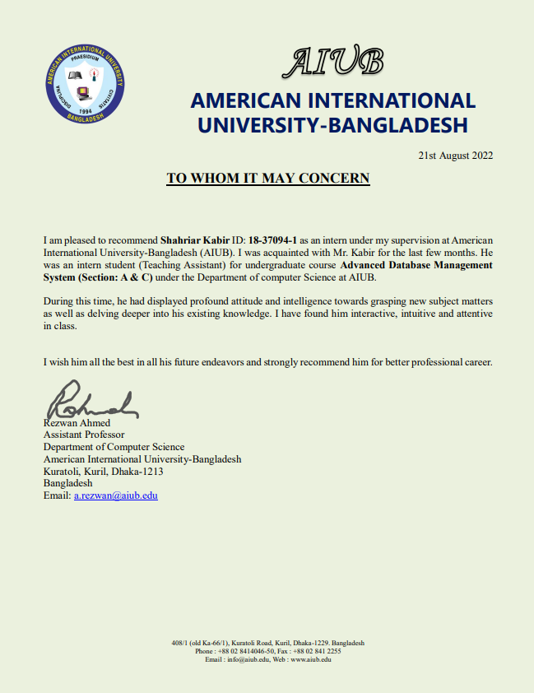

**REFERENCES**

[1] A. I. U. B. S. D. D. (itsd.aiub.edu), American International University-Bangladesh (AIUB). [Online]. Available: https://www.aiub.edu/about/general-information. [Accessed: 16-Apr-2021].

[2] Anjum, S., 2020. Impact of internship programs on professional and personal development of business students: a case study from Pakistan. Future Business Journal, 6(1).

[3] INFORMATION: Overview of American International University-Bangladesh (AIUB). American

International University – Bangladesh Website. Retrieved April 14, 2021 from http://www.aiub.edu/about/information/

[4] Niebauer W (1978) The great equalizer: job experience. Community Coll Journal 7(1):23–24

[5] RESOURCES: AIUB ICT Facilities. American International University-Bangladesh Website. Retrieved April 14, 2021 from http://www.aiub.edu/about/resources/

[6] RESOURCES: Laboratory Facilities. American International University-Bangladesh Website. Retrieved April 14, 2021 from http://www.aiub.edu/about/resources/

[7] RESOURCES: Library Facilities. American International University-Bangladesh Website. Retrieved April 14, 2021 from http://www.aiub.edu/about/resources/

[8] Tynjälä P (2008) Perspectives into learning at the workplace. Educ Res Rev 3(2):130–154

**APPENDICES**

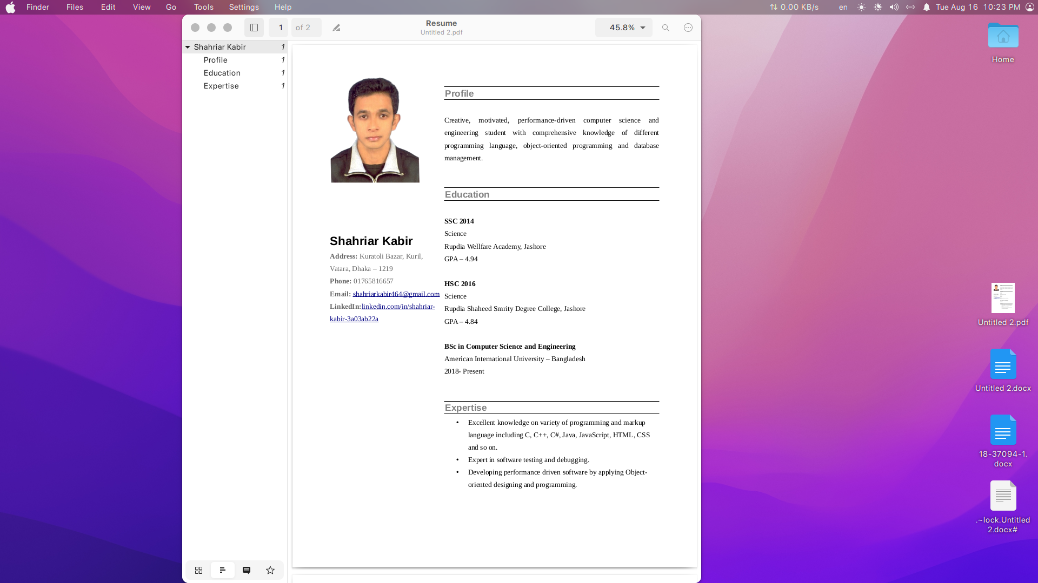

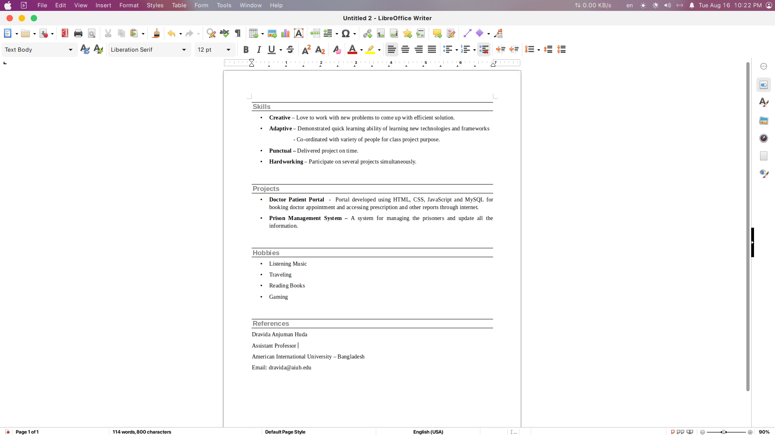

**APPOINTMENT LETTER** 